Work Exp Explained

C++->I worked for Marelli and ford on cluster system, writing code for cluster program, designing detailed design plans for code implementation for proposed Change Request. An maintaining the traceability matrix. Getting the DDP reviewed and writing code in cpp with QT Framework. What is the DDP. The DDP includes the following things:

1. Blocks of the program
2. Communication between these block and there interfaces, similar to an er diagram
3. Details of each block.
4. Dynamic behaviour of each software unit.
5. Algorithm and pseudocode for new software component.
6. If you come up with multiple code implementation for given task then also PUGH matrix for comparison of these processes.

Programs interacts with ECU’s and work on the data provided by these ECU’s. CAN db refrence to identifiy ECU’s signals and Messages travelling on can. VectorCANDB is used for simulate ECUs, you can make your program generate message similar to an ECU, which can be accepted by an ECU. Cattle Script. The Databse differs from Oem to oem

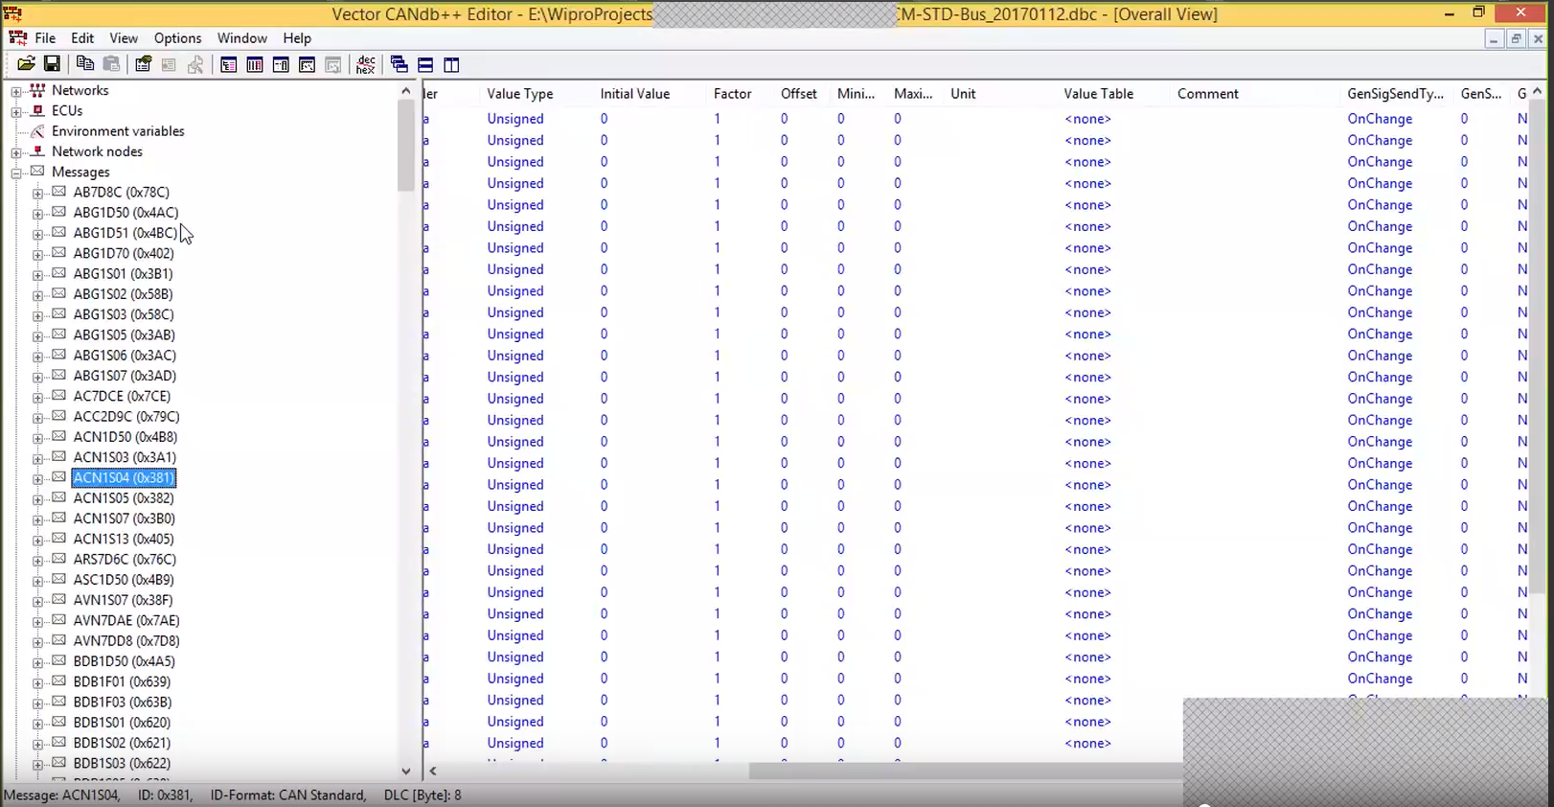

**So basically theres 2 types of software developed in auto motive by ford engineers.**

1. **Cluster Software-** Software that runs on instrument cluster.

Mordern cluster has it’s own processor (vehicle processor), memory eprom, nvram even OS etc. So it’s a computer system on it’s own.

Cluster programs are designed in a way to receive inputs from ECU SC and display that info to driver in a convenient way.

1. **ECU software-** Software that runs on ECU.

**Steps:**

1. Create a abstract mapping of functions in the vehicle= ASD ARXML
2. Create a virtual mapping of all the software components= VFB

This VFB acts as a abstract layer between SCs and facilitate their communication

1. Create a UML System Design for each individual ECU= ARXDML. ARXML will contain info like topology, ECU configuration, Behaviour, ports, definitions of each SCs
2. Now using the ARXML and VFB we start creating our Software components or Sub-Software Component
3. Autosar architecture and methodologies are used to develop these software components. And hence are called autosar components.
4. Note:- Autosar framework is designed to make platform independent application, hence using this framework applications can be developed in any programming language like java and python too. The common interfaces provided in auto sar ensure applications written in diff programming languages can inter-operate.

Tools used:

DaVinci configurator- Used to custom configure the BSW components

ARTOP- Tools framework to develop autosar components

JAVA-> I worked for ford for their automotive apps for like they had this desktop app which their technicians used to connect with car OBD, and another app for service center management. I used to work for the later app writing java code using spring boot framework also using hibernate. Code optimization, find handling un-handled exeception, code formatting, code cleaning.

Programs interacts with ECU’s and work on the data provided by these ECU’s. CAN db refrence to identifiy ECU’s signals and Messages travelling on can

I wrote a java code for a hibernate module which would fetch customer complaint if any from the company database.

Code debugging and optimization, checking for unchecked exceptions. Escalating high ASIL bugs

ECU Development

We work on development of 3 ECUs mainly (Sync, TCU, ECG), I can’t tell you the names but I can tell you this much that one ECU was like the central ecu of the car while the other two where responsible for the Ford Sync feature.

ECG is the central gateway for the ECUs.